**Machine Problem 1: Python**

1st Case: if n <= 9 and n >= 0

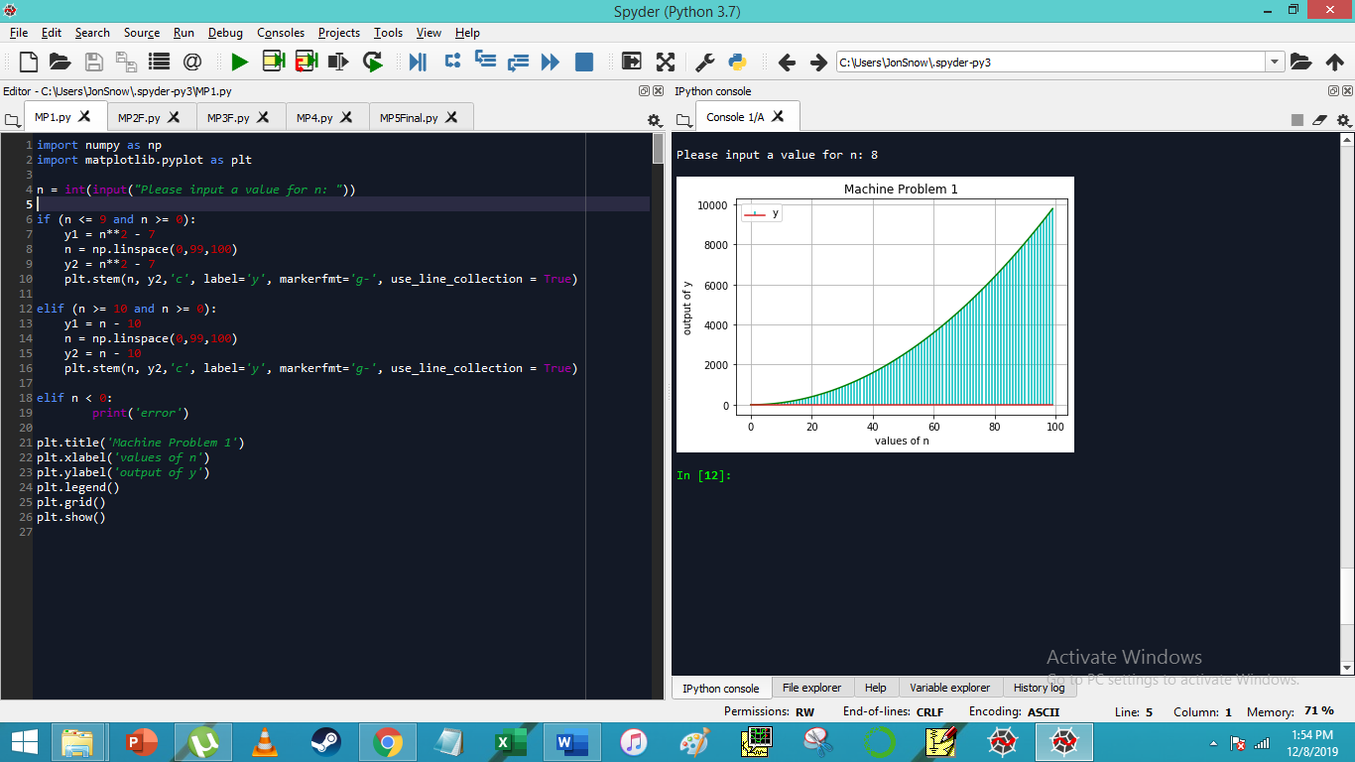

Graph:

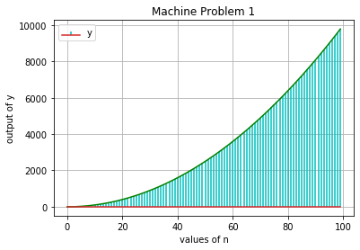

2nd Case: if n >= 10 and n >= 0

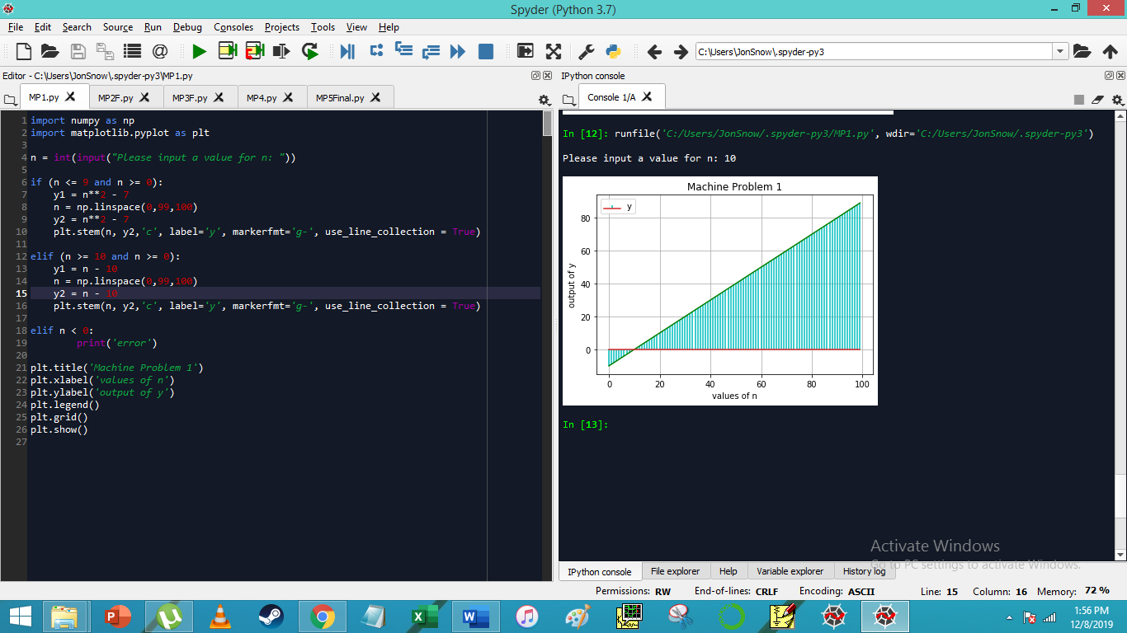

Graph:

